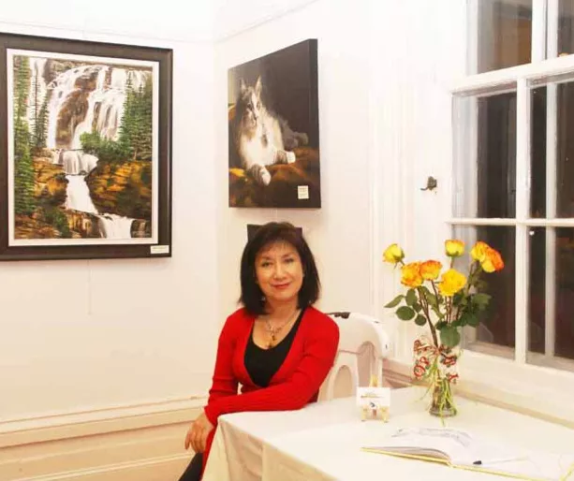
BERNADETTE LAU
Artists of
Asian Heritage Culture Festival
"Natural Asian" Art Exhibition
May 21- 29, 2022
Bridlewood Mall, Toronto
Presented by
Canada One Family Network

Graduated from the Ontario College of Art & Design, Bernadette started out her career working for McClean's Magazine. She then began her freelancing voyage and has been providing illustrations for trade and educational publishers since 1979. Her work has been published in many ads, books, and magazines in Canada for 30 years.

Major clients include Harlequin Enterprises, Addison Wesley, Harcourt Brace, Pearson Scott Freeman Publications, Canadian Legion Magazine in Ottawa, Coca Cola, Bank of Montreal, Reader's Digest, Art Plus Design studios, Canadian Living Magazine, Gage Publications, Noma Lights, Otravin, Bear Canyon Design Studios in New Mexico U.S., Cadbury, Sequine Advertising Studios, Cliff Smith Design Studios, Word & Image Design Studios.

Bernadette enjoys working in a variety of traditional mediums including water colors, gouache, pencils, pen and inks, color pencils, acrylics and oil colors.

Bernadette is currently teaching art classes. Her first love is painting, and through her paintings, she wishes to share with you the beauty in simple everyday life.

Galleries:
RedEye Studio Gallery, Distillery District, Toronto
CCM Centre Community Gallery and Studio
McKay Art Gallery, Unionville, Markham

Exhibitions:
One of a Kind Show 2007
Bernadette Lau Teacher and Students Art Exhibition 2010, 2011, 2012, 2013, 2014, 2015, 2016, 2017, 2018, 2019.

Teaching:
Acrylic Painting at the Varley Art Gallery.

Contact:

Email: Bernadette.lau@sympatico.ca
Tel.: 416-291-0524
Web: www.blau-illustration.com

