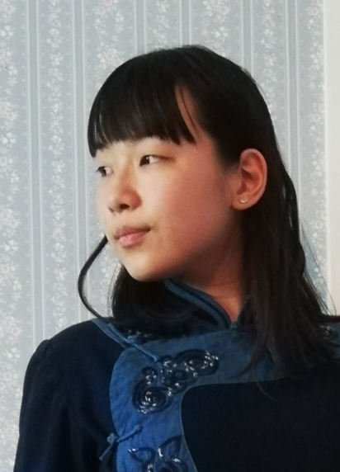

Tianyu Chen, born in 2000, Nanjing, grew up in Toronto in 2003. She graduated from the Department of Literature at Queen's University. Tianyu devoted her free time to practicing and studying drama, literati culture, tea ceremonies, and flower arrangements. Since her young age, she has developed her skills as a demonstrator in arts and culture events and stage shows. Tianyu is also an active martial arts practitioner, training since eight years old. As a disciple of Grand Master Yongmei Li, primary gatekeeper of Shaolin Mizong Kongfu and trainer of many champions. She developed Taichi hand push with Sifu Hua Ming practicing and Lion and Dragon Dance Kongfu and paintings with Sifu Lat Yip. Widening her expertise, she also developed her Poetry Recitation skills in literati ceremonies demonstration.

陳天鈺，2000年出生於南京，2003年移居多倫多，畢業於加拿大皇後大學文學系。她空閑時間學習戲劇、文人文化、茶道和插花等。自孩提時，她就培養文化藝術活動和舞臺表演技能。她也是一名武術愛好者，8歲開始跟隨少林秘宗李永美師傅習練傳統武術，明華師傅習練太極推手，葉浪師傅習練舞獅舞龍功夫和绘画。她還拓寬專業知識，於文人儀典中表演詩詞朗誦。

